SIMATS ENGINEERING

ASSESSMENT TOOL 2

COURSE NAME: Database Management Systems COURSE CODE: CSA05

COURSE OUTCOME COVERED

CO2: Apply the relational model, relational algebra, SQL query structures, and views to solve database querying and data manipulation problems. (BL3, BL6)

Activity Tool : Scenario-Based Task (High) Assessment Tool Weightage: 35%

Dr

QUESTIONS Total Marks: 50
Q.No | Question | Bloom's Level | Marks
1 | Given the scenario of a School Management System, identify relations and write SQL to list all students with their class teacher and grade. | BL3 – Apply | 5
2 | A hospital wants to track patient appointments. Design the relational schema and write SQL to find doctors with more than 10 appointments this month. | BL3 – Apply | 5
3 | In an e-commerce scenario, write SQL queries using sub-queries to find products that have never been ordered. | BL3 – Apply | 5
4 | For a university database, write relational algebra expressions to find students enrolled in both 'DBMS' and 'OS' courses. | BL3 – Apply | 5
5 | Given a payroll scenario, create a view showing employees whose salary is below department average and write a query to update their salary by 10%. | BL6 – Create | 5
6 | In a banking scenario, apply JOIN operations to retrieve customer account details, transaction history, and branch information. | BL3 – Apply | 5
7 | A retail store needs daily sales summary. Write SQL with GROUP BY and HAVING to report total sales per category exceeding Rs. 10,000. | BL3 – Apply | 5

8 | For a library system scenario, construct tuple relational calculus expressions to find members who borrowed books from all genres. | BL3 – Apply | 5
9 | Given an inventory management scenario, define CHECK and FOREIGN KEY constraints and demonstrate their enforcement through SQL. | BL3 – Apply | 5
10 | Design a relational schema for an HR system and create materialized views for monthly attendance and performance summaries. | BL6 – Create | 5

Code of Conduct:
G Vyshnavi(192525260)
I (Name / Reg No) certify that this submission is my original work and that I have adhered to the guidelines specified for this assessment. I understand that any violation of academic integrity rules will result in disciplinary action.
G Vyshnavi
Signature of the student:

1.Given the scenario of a School Management System, identify relations and write SQL to list all students with their class teacher and grade.

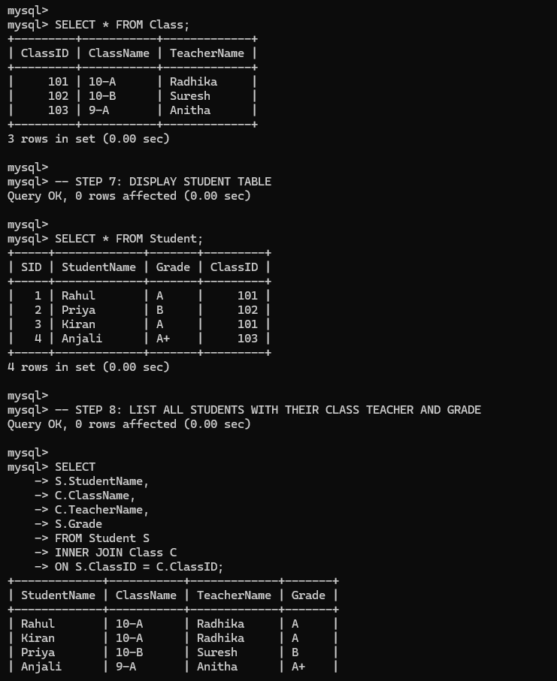

- A hospital wants to track patient appointments. Design the relational schema and write SQL to find doctors with more than 10 appointments this month.
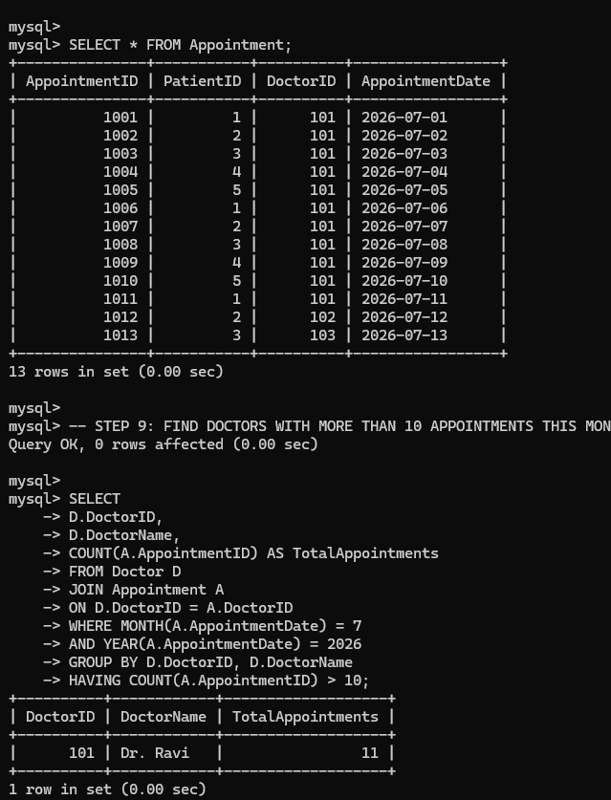

3.In an e-commerce scenario, write SQL queries using sub-queries to find products that have never been ordered.

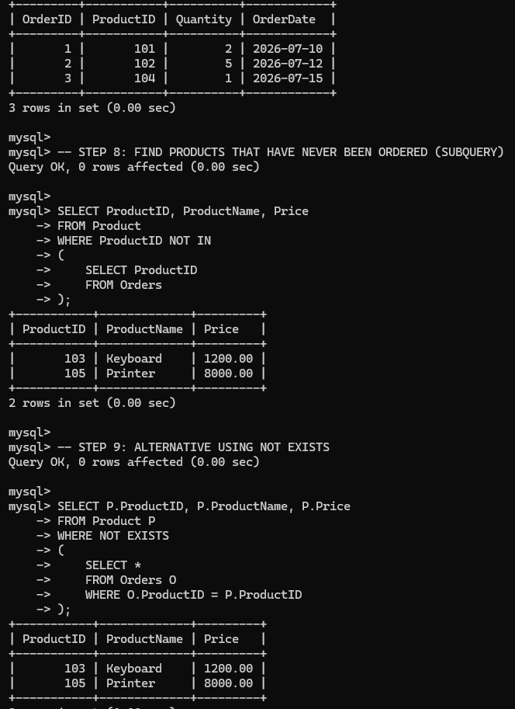

4.For a university database, write relational algebra expressions to find students enrolled in both &#39;DBMS&#39; and &#39;OS&#39; courses.
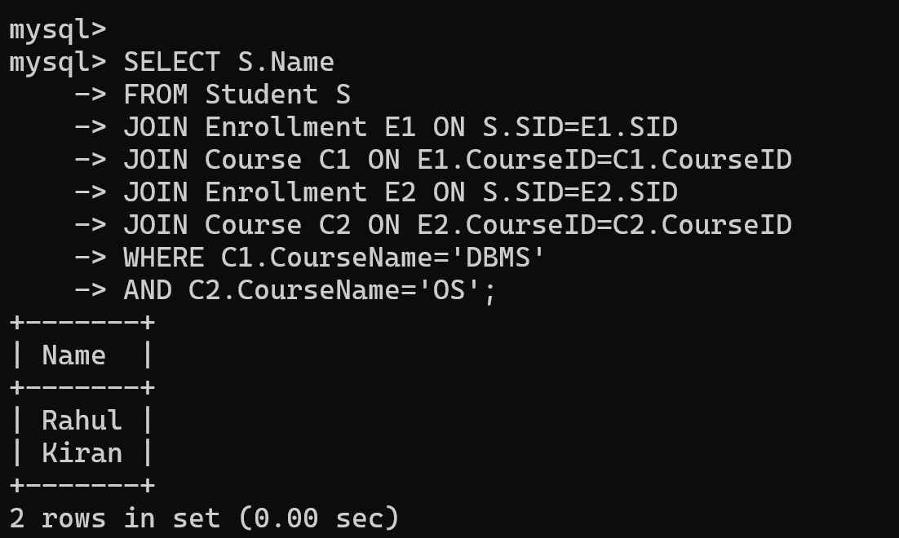

- Given a payroll scenario, create a view showing employees whose salary is below department average and write a query to update their salary by 10%.
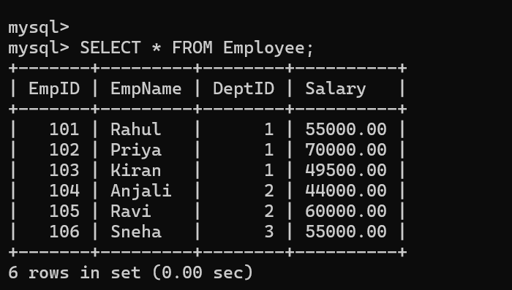
- In a banking scenario, apply JOIN operations to retrieve customer account details, transaction history, and branch information.

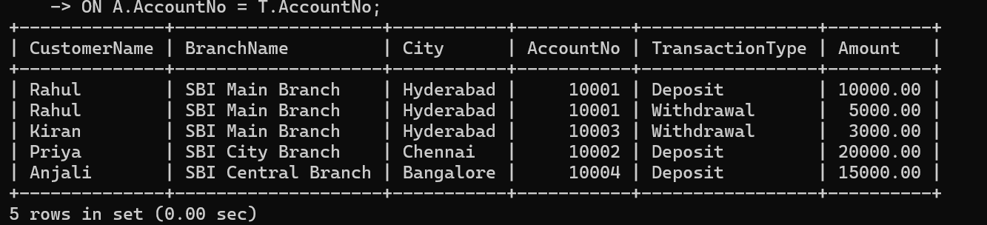

- A retail store needs daily sales summary. Write SQL with GROUP BY and HAVING to report total sales per category exceeding Rs. 10,000.

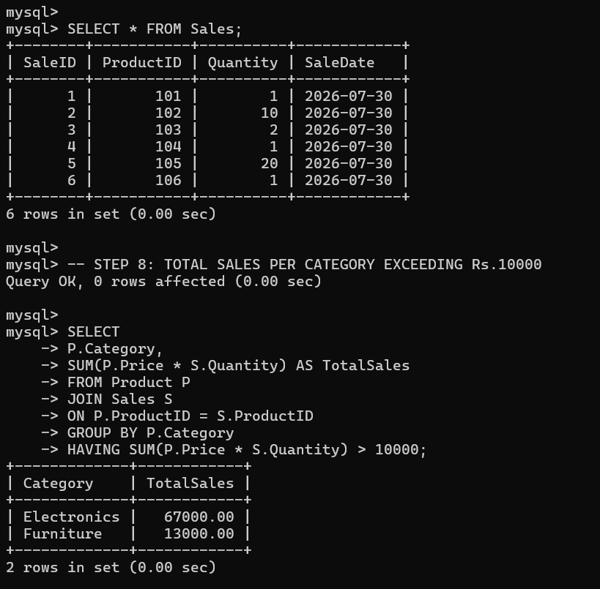

- For a library system scenario, construct tuple relational calculus expressions to find members who borrowed books from all genres.
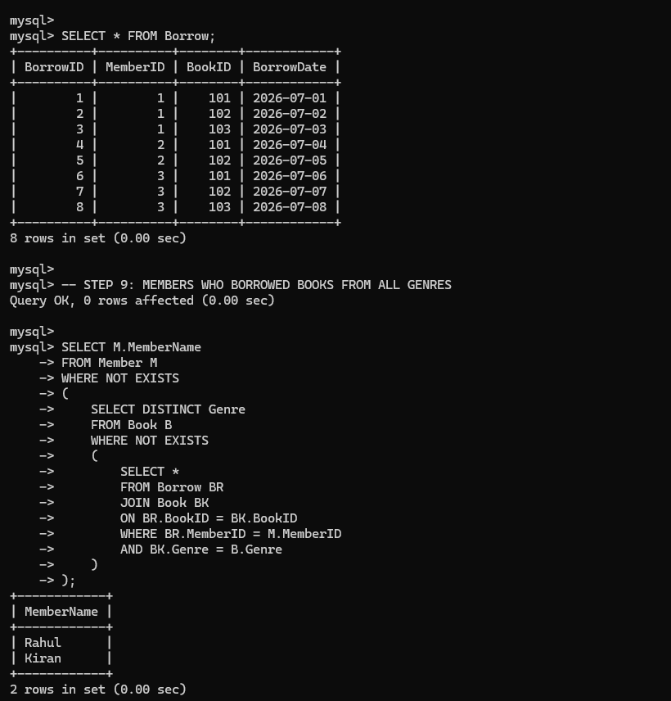

- Given an inventory management scenario, define CHECK and FOREIGN KEY constraints and demonstrate their enforcement through SQL.
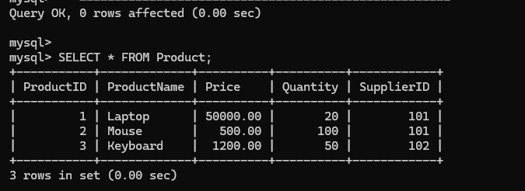

10.Design a relational schema for an HR system and create materialized views for monthly attendance and performance summaries.

